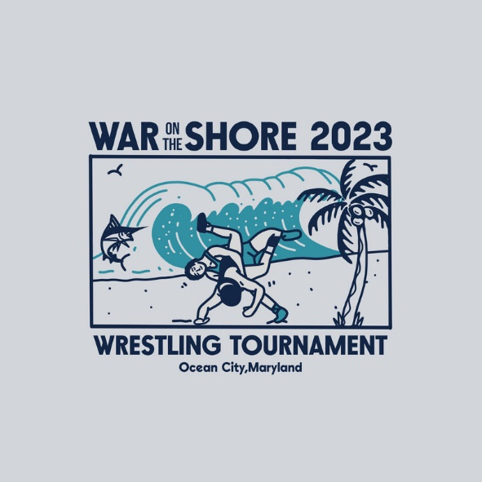
War on the Shore – Invoice / Confirmation
Payable to: Stephen Decatur High School
Due by Dec. 1
Stephen Decatur High School Wrestling
9913 Seahawk Rd.
Berlin, MD 21811
Contact Todd Martinek if you have questions
443-614-2743 or toddmartinek@gmail.com
Team Name
Head Coach Name
Head Coach Contact Info – Cell and email
Athletic Director Name
- D. contact Info -
Athletic director signature - _________________
Total Amount Due
Amounts | Total Paid
Varsity Team fee $450
JV fee – $20 per wrestler
Girls - $20 per wrestler
Total Amount Enclosed - ___________________

